The LAB_MAIN_INT was created as follow | 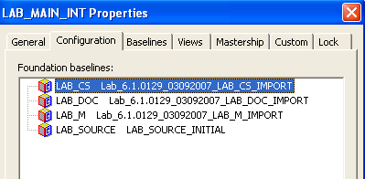
The 6.1 baselines were imported in base CC and than the labels imported as baselines.  These baselines are not “real” UCM baseline and deliver/rebase operations are restricted for this type of baseline.  So, we should not create the 6.3.0 or 6.3.1 project off of that.  For the same reason, we don’t want to import the 6.3.* baselines into the Base CC main (different than LAB_MAIN) and then covert the base CC labels into baselines. | 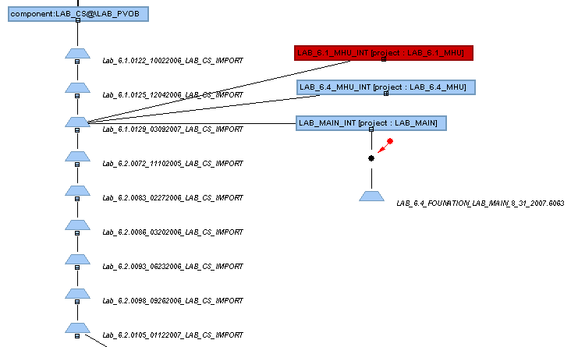
So, my suggestion is to create the LAB_6.3.0 Project off of LAB_6.4_Foundation…(this is the first real UCM baseline in LAB_MAIN).  Since the timeline is not quite right (6.4 first and then 6.3), we need to ensure that all files are going to be imported as is from Harvest. We cannot allow CC to compare dates and skip files during the import.  For that, we can reuse a script that I wrote for importing CDHT code for COPATH. All that the script does is to compare two folder structures (a CC View and Harvest latest) and generate a list of co/ci -identical/mkelem commands as appropriate. | \\az-ccvob2\COPATH\CDHT_Vanilla\Log\copath_import.pl  - Create 6.3.0 UCM Project based in the LAB_MAIN project  - Run copath_import.pl to create the import script  - Run import script  - Create/Recommend 6.3.0 Baseline
Once 6.3.0 is imported, we repeat the process for 6.3.1.  The new 6.3.1 UCM Project should refer to the 6.3.0 baseline now in ClearCase. | - Create 6.3.1 UCM Project based in the 6.3.0 project  - Run copath_import.pl to create the import script  - Run import script  - Create/Recommend 6.3.1 Baseline
Once we validate that the ES_6.4 is integrated properly, we then deliver to the LAB_Main Project | - Deliver 6.3.0 baseline to LAB_MAIN (not sure if that is necessary, the next step should include this baseline)  - Create new LAB_MAIN baseline: 6.4_6.3.0_code_integration  - Deliver 6.3.1 baseline to LAB_MAIN  - Create new LAB_MAIN baseline: 6.4_6.3.1_cde_integration
If the ES_6.4 project was already created, we can then deliver 6.3.1 baseline to the ES_6.4 project.  Otherwise we would create it starting from 6.4_6.3.1_cde_integration baseline | - Rebase ES_6.4 from LAB_Main or  - Create ES_6.4 Project
VISTA, SLASH can then rebase from LAB_MAIN.

MLAR most likely will have to use Merge Manager to get the updates, since it was created based in the 6.1 (non UCM) baseline.
Off course, we still have those ES changes in MLAR to deal with…

